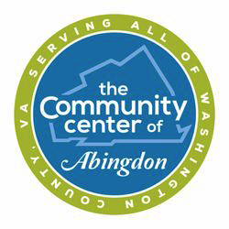 Meals on Wheels Application

Date:__________________ Date of Birth:____________________
Meals on Wheels recipients are required to notify the Center if they are hospitalized and/or will be unable to answer the door. If you are not home for whatever reason, you will need to place a cooler outside the door or we will be unable to deliver your meals. If you move or are hospitalized for more than a few days, please notify the center immediately. If you do not answer the door 3 times in a row w/o contacting us, we will call for a well check from local police dept. Then you will be removed from the program until you update an application, contact the center and requalify.

Your name:__________________________________________________________________

Your Home Phone Number: ______________________Cell Number:____________________

Your address: _________________________________________________________________

Other Living With You: ________________________________________________________

Your email address (if available): __________________________________________________

Is there a pet in the house? Yes:______ No:______ What kind:__________________________
Is it hyperactive? Yes: _____ No: ______ Does it Bite: Yes: _____ No: ________

Emergency Contact person outside the home

Name: ___________________________________ Phone: ________________________

Relationship: ______________________________

Doctors Name: __________________________________________________________________

Are you a Veteran: Yes ______ No: ______ Branch of Service: _________________________

Any Health problems? Check those that apply:

- Walking  - Arthritis  - Cancer  - Heart | - Diabetes  - Vision  - Hearing  - Alzheimer's/Dementia | - Joint Replacement  - High Blood Pressure  - Brain  - Other: _______________
Mail to: The Community Center of Abingdon OR email to: info@theccoa.org
300 Senior Dr Abingdon, VA 24210 Phone: (276) 628-3911 Fax: (276) 628-5859

All meals to recipients are provided free of charge. The Community Center of Abingdon is a 501(c)3 Non-Profit Corporation funded by donations and sponsors. Donations are welcome but are not required.

